# Name: LAI WEIZHONG

# Id: 28969367

# Abstract

This project show us the algorithm of face detection. In this report, I’ll introduce the Haar-like feature, Adaboost. The Harr-like feature have three different kinds of features, two rectangular feature, three rectangular feature and diagonal feature.

Adaboost is an iterative algorithm, the core idea is to develop different weak classifiers using the training set, and these weak classifiers are then assembled to form a strong classifier.

# Haar-like feature

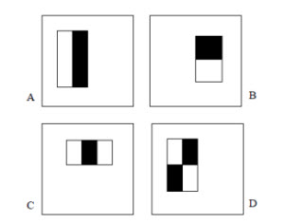

* A and B is two rectangular feature, C is three rectangular feature, D is diagonal feature. Is calculation of feature is using the black area minis white area.
* Before the calculation, it need to be normalized. $u\left(x,y\right)=\frac{i\left(x,y\right)-μ}{cσ}$

U(x,y)represent the normalized image, and i(x,y)represent the original image, $σ$

Represent the standard deviation.

* Use the integral image to calculate feature.

Integral image: $ii\left(x,y\right)= \sum_{x^{'}≤x,y^{'}≤y}{i(x^{'},y')}$

4

3

2

1

C

B

A

D

Suppose S(i) is adding up all the left side and the top pixel. i = 1, 2, 3,4…..

The sum of D is S(1)+S(4)-S(2)-S(3). So we can easily calculate all every part of pixel.

# The main idea of Adaboost

We train a classifier for each feature, then we measure the error of each classifier, and we select the minimum error of classifier, then use the minimum error to calculate the weight, update the weight. Repeat the process. Eventually, it forms a strong classfier.

# experiment

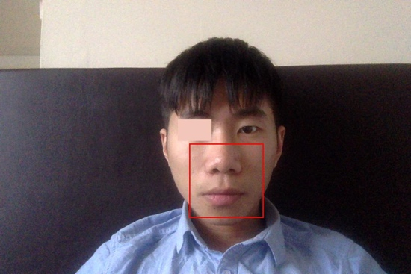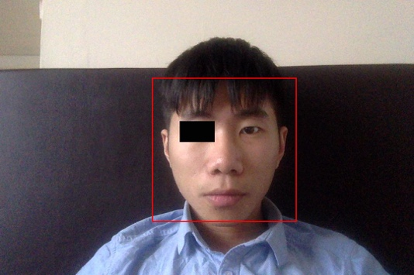

If I use a black area to cover one eye, my face will be detected. but if I use brighter color area to cover my eye, my face will only be detected below the eye.

I guess that the detector will test the color between the eye and check, if the color is different it will pass the detector as one feature. But if the color is the same it will calculate the sub area.

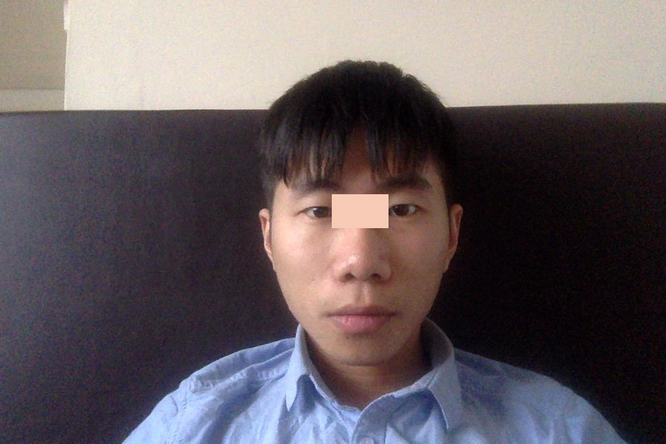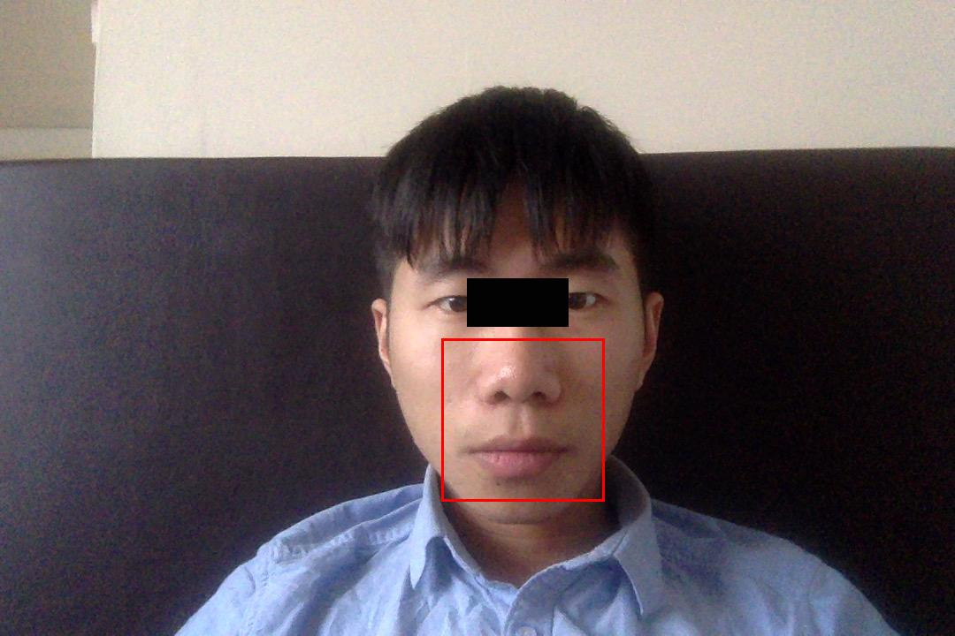

use one black rectangle cover the area between the two eyes. It will not be detected blow the eye.

use a brighter color rectangle cover the area between the two eyes. It will not be detected.

The area between the two eyes will be another feature to be detected.

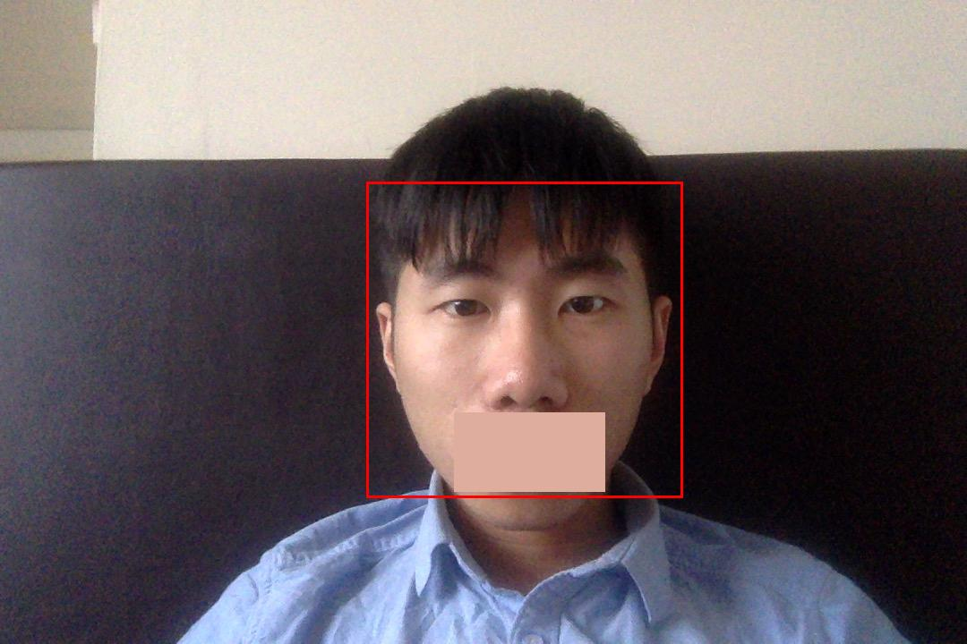

if a black area covers the mouth, it can’t be detected as a face.

if the mouth is covered by a brighter color, it can be detected as a face.

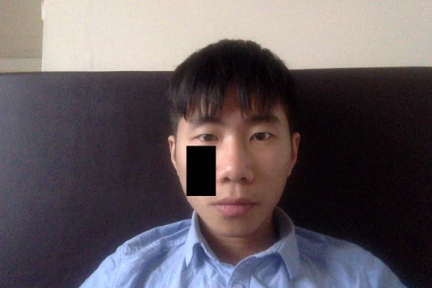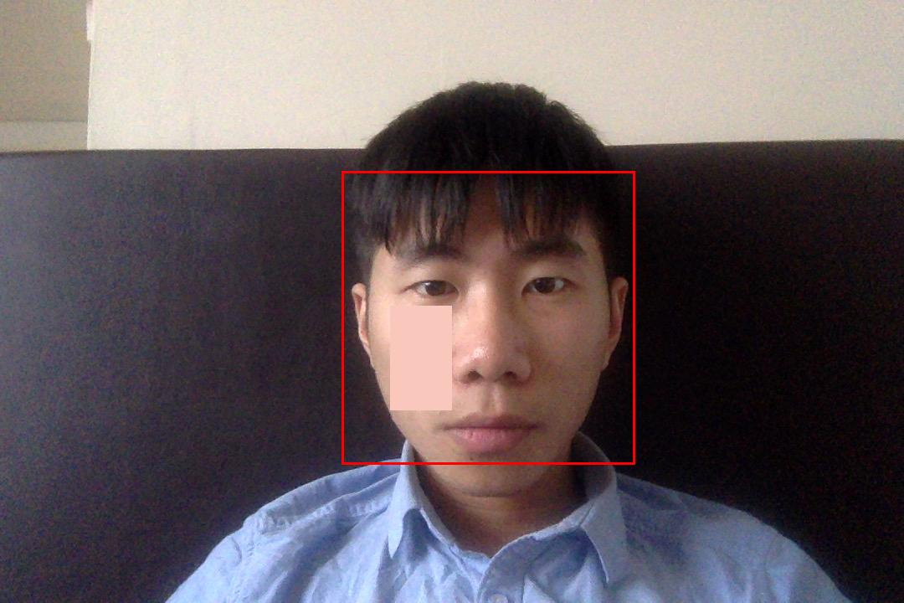

if the black area covers the cheek, it will not be detected as a face.

if a white area covers the cheek it will be detected as a face.